**Hypertext Markup Language**

1. Hypertext Markup Language (HTML) is the standard markup language for creating web pages and web applications.
2. Opening tag and a closing tag
3. Editor
   1. Any normal text editor or in IDE
4. Execute
   1. Open in a browser
5. 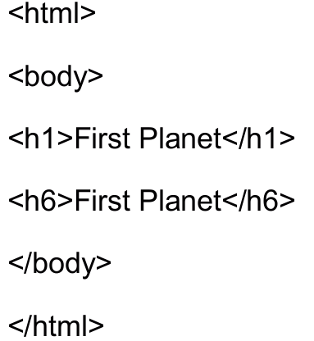
6. Link - <a href="<http://www.gmil.com>">Gmail</a>
7. Image - <img src="word.jpg" width="104" height="142" />
8. Comments - <!--It will not be displayed→
9. Formatting tags -
   1. b-Bold
   2. i-Italic
   3. code- Computer code
   4. sub-Subscript
   5. sup-Superscript
   6. <s> - Strike
   7. <u> - Underlined text
   8. Example:
      1. 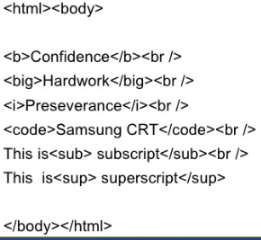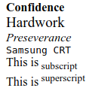
10. Attribute
    1. Align
    2. Bgcolor
    3. Color
11. Style example
    1. 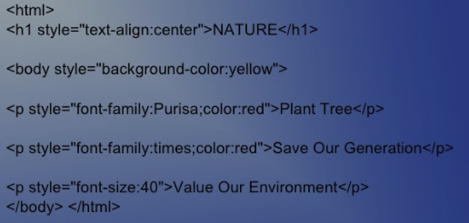
12. Table
    1. 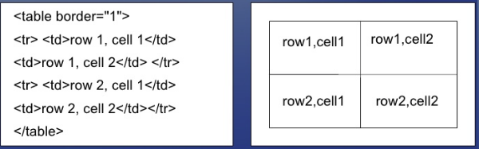
13. Lists
    1. Ordered list <ol><li>item</li></ol>
    2. Unordered lists <ul><li>item</li></ul>
    3. 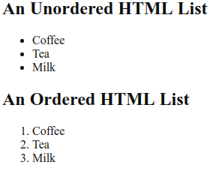
14. HTML forms
    1. HTML Forms are used to select different kinds of user input.
    2. A form is an area that can contain form elements.
    3. Form elements are elements that allow the user to enter information like,
       1. text fields - <input type="text" name="firstname" />
       2. textarea fields - <textarea name="message" rows="10" cols="30"> </textarea>
       3. drop-down menus - <select name="cars"> <option value="audi">Audi</option> </select>
       4. radio buttons
       5. Checkboxes
       6. Action Attribute and the Submit Button,etc.
    4. <form action="/action_page.php" method="get">
    5. GET and POST request - HEAD, PUT, DELETE, OPTIONS,
    6. https://www.w3schools.com/code/tryit.asp?filename=FPMOI08WKYV3
15. Iframe
    1. With frames, you can display more than one HTML document in the same browser window.
16. XML - <https://www.w3schools.com/xml/>
17. RSS Feed - RSS is a type of web feed which allows users to access updates to online content in a standardized, computer-readable format. These feeds can, for example, allow a user to keep track of many different websites in a single news aggregator.

**Assignments(8 hrs):**

1. Create a form to register the details of the student to a school(Include as much as detail collection fields in the form)
2. Build a table like below
   1. 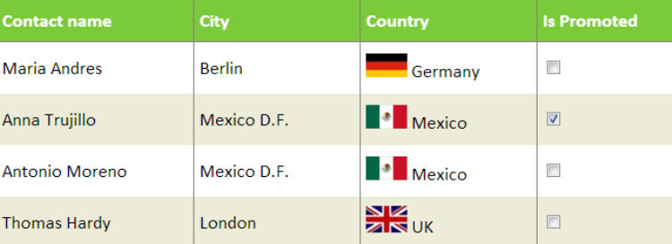
3. Build a design like below
   1. 